SQL Execution Order

SQL Query Execution Order
Understanding SQL execution order is critical for writing optimized and correct queries. SQL does not execute queries in the same order they are written.
Logical Execution Order
- FROM – Identifies source tables
- JOIN / ON – Applies join conditions
- WHERE – Filters rows
- GROUP BY – Groups rows
- HAVING – Filters groups
- SELECT – Selects columns/expressions
- DISTINCT – Removes duplicates
- ORDER BY – Sorts result set
- LIMIT / OFFSET – Restricts number of rows
Key Interview Points
- WHERE cannot use column aliases
- HAVING works on aggregated data
- ORDER BY can use aliases
- Execution order is logical, not physical

Diagram:
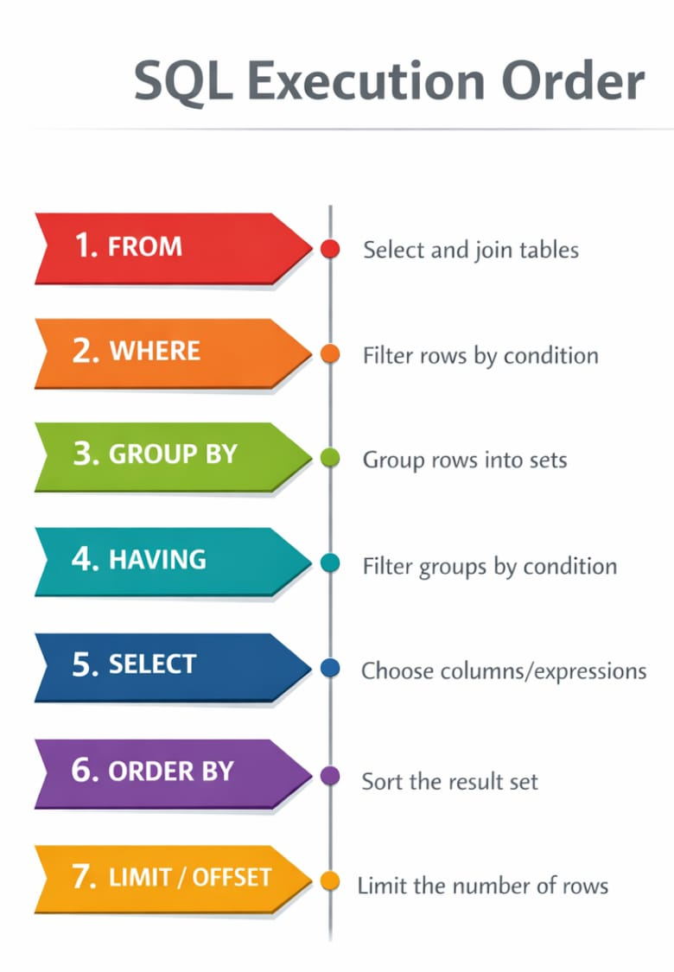

Example:
SELECT dept, COUNT(*)
FROM employees
WHERE salary > 50000
GROUP BY dept
HAVING COUNT(*) > 5
ORDER BY dept;
This query follows the logical execution order listed above.

